JOINT STATEMENT: Nursing Organizations of Color Respond to Proposed Federal Limitation of Student Loan Access for Nursing
November 19, 2025
Our organizations, representing professional nurses of color across the United States, stand with the American Nurses Association, Institute for Health and Social Equity, Nursing Community Coalition, and the American Association of Colleges of Nursing in expressing deep concern over the Department of Education's proposed redefinition of "professional degree" programs that excludes nursing from federal loan eligibility. This policy will create significant barriers to advanced nursing education at a critical time for our nation's healthcare workforce.
Nurses of color already carry disproportionately higher student loan debt than their white counterparts. Excluding Master of Science in Nursing (MSN), Doctor of Nursing Practice (DNP), and nursing PhD programs from professional degree classification will create insurmountable financial obstacles for aspiring nurse leaders of color who are essential to providing care in medically underserved communities. This threatens the pathway of nursing faculty, nurse practitioners, and nurse scientists of color at a time when workforce diversity has never been more critical to improving patient outcomes and healthcare access.
The Department's proposed framework requires that professional degree programs signify completion of academic requirements for beginning practice, represent professional skill beyond a bachelor's degree, require professional licensure, and be doctoral-level programs. Advanced practice registered nurse programs meet every criterion stated in the department's framework. Graduates of these programs are independent providers, healthcare systems leaders, researchers, and educators who require professional licensure and provide direct patient care. Post-baccalaureate nursing education is rigorous and essential to our nation's healthcare needs. In many rural, tribal, and underserved communities, advanced practice nurses (nurse practitioners, certified nurse anesthetist, certified nurse midwives,and clinical nurse specialist) are often the only accessible healthcare providers. Their exclusion based solely on Classification of Instructional Programs (CIP) code classification contradicts the Department's own stated criteria.
Healthcare workforce diversity directly improves patient outcomes, increases access to care in underserved areas, and reduces health disparities. Nurses of color are more likely to practice in medically underserved communities and provide care to patients from similar backgrounds. Restricting loan access for advanced nursing education will diminish the pipeline of diverse providers serving the communities that need them most and perpetuate existing health equity gaps.

We urge the Department of Education to:
- Revise the proposed definition to explicitly include post-baccalaureate advanced nursing education programs as professional degree programs
- Engage meaningfully with nursing stakeholders, especially organizations representing nurses of color, before finalizing this rule
- Recognize the professional status of nursing as commensurate with other health professions
Nurses represent the largest segment of the healthcare workforce and the health of our nation depends on assuring that we continue to educate a robust, diverse nursing workforce. We stand ready to work collaboratively to ensure federal policy supports the healthcare workforce our nation requires to care for all citizens with a high level of dignity, respect, and compassion as codified in the nursing code of ethics.

About Us
This statement reflects the shared commitment of professional organizations representing over one million racially and ethnically diverse nurses across the United States, including:
- Academy of Diversity Leaders in Nursing
- Alliance of Cosmetic Nurse Practitioners™
- Asian American Pacific Islander Nurses Association
- Association of Black Nursing Faculty
- Black Nurse Collaborative
- Black Nurses Week
- Black PhD Nurse Scientists
- Chi Eta Phi Sorority, Inc.®
- Deborah Stamps Consulting, LLC
- DLJames Consulting
- Diversity in Nurse Anesthesia Mentorship Program
- DNPs of Color
- Ghanaian Diaspora Nursing Alliance
- The International Association of Latino Nurse Faculty/Nurse Leaders
- Multicultural CRNA Conference Organization
- National Alaska Native American Indian Nurses Association
- National Association of Hispanic Nurses
- National Black Nurse Practitioner Association
- National Black Nurses Association
- Network of Black Male Nurse Leaders
- Philippine Nurses Association of America
- Society of Latinx Nurses
- The Institute for Health and Social Equity, Inc.
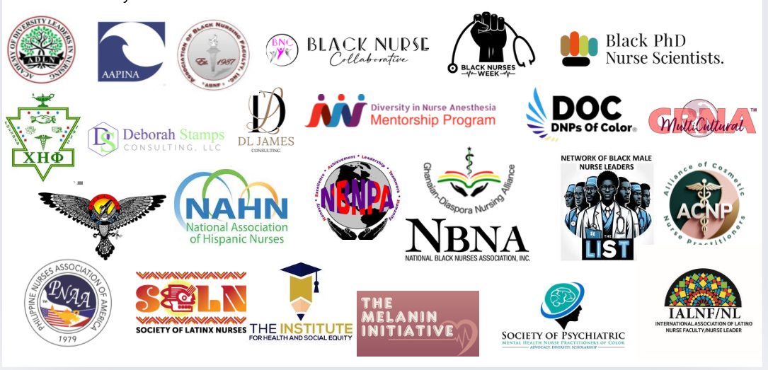
- The Melanin Initiative Podcast
- The Society of PMHNPs of Color

